**Project 1**

1. Imported collections using below commands:

mongoimport --db proj1 --collection Addressing --type csv --file Z:\MongoDB\911_Addressing_-_Street_Name_Master_List.csv --headerline

mongoimport --db proj1 --collection Purchase_Order --type csv --file Z:\MongoDB\Purchase_Order_Quantity_Price_detail_for_Commodity_Goods_procurements.csv --headerline

mongoimport --db proj1 --collection Waste_Collection --type csv --file Z:\MongoDB\Waste_Collection___Diversion_Report__daily_.csv --headerline

mongoimport --db proj1 --collection Consumer_Complaints --type csv --file Z:\MongoDB\Consumer_Complaints.csv –headerline

Below are the screen shots of the imported collections:

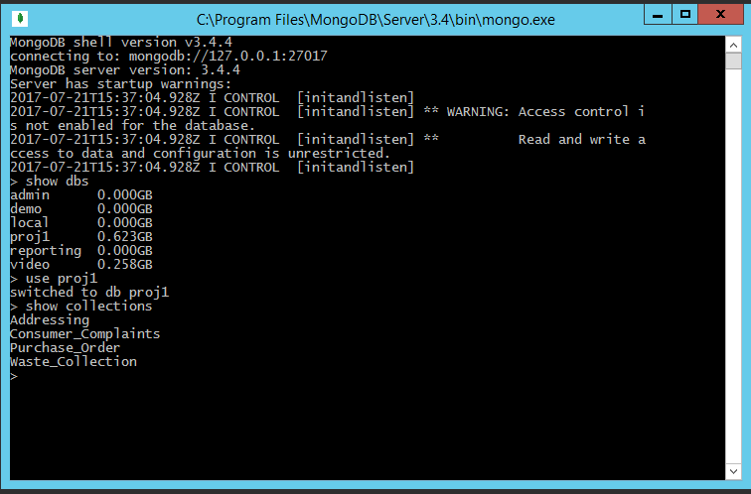

1. Crud Operations:
2. Cursor Batches:

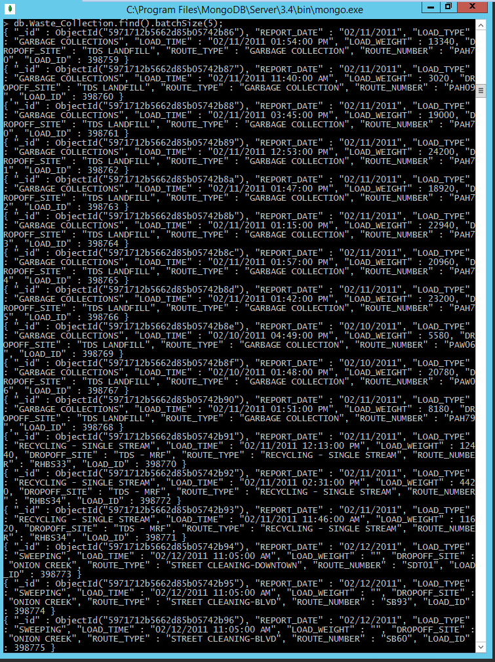

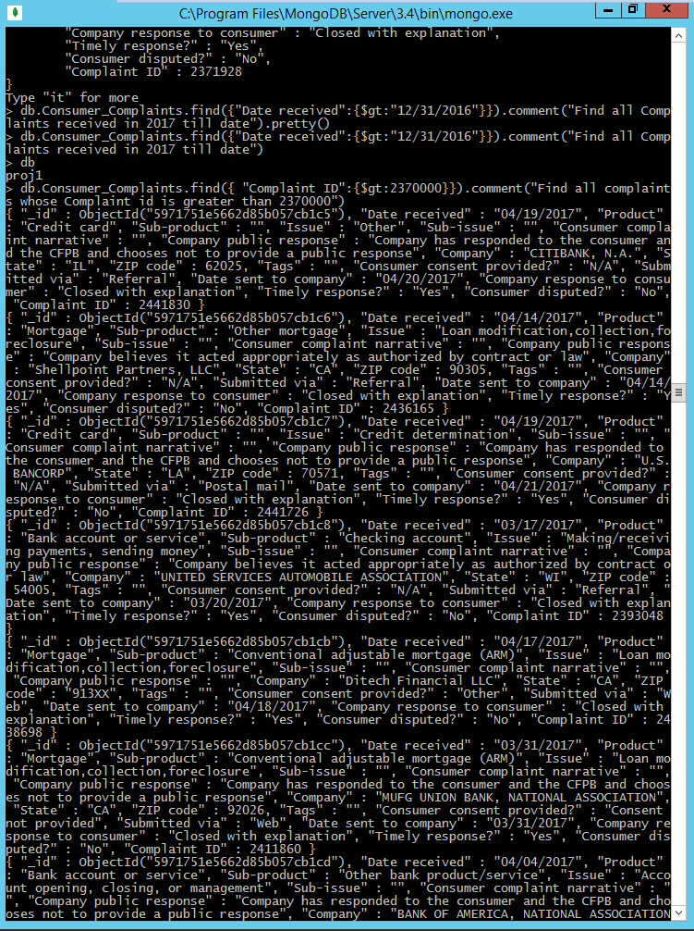

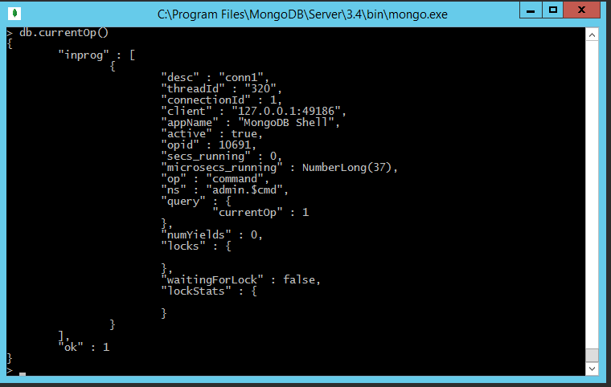

1. Creating & dropping db & collection

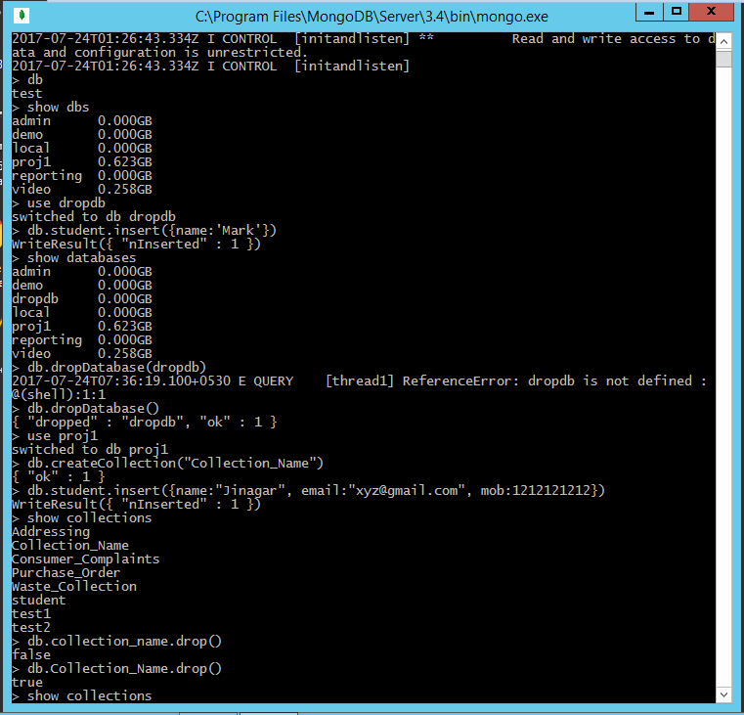



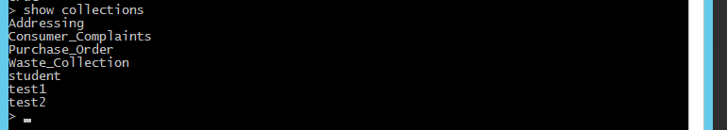

1. Select only required fields from documents

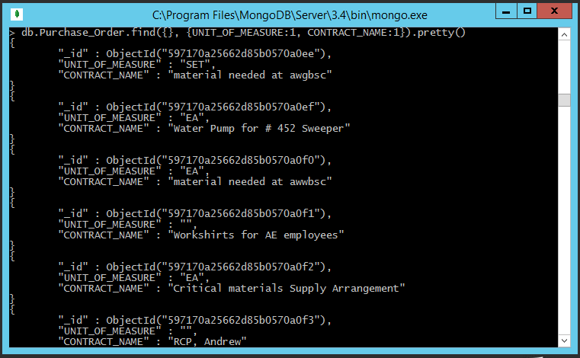

1. Count the total no of documents

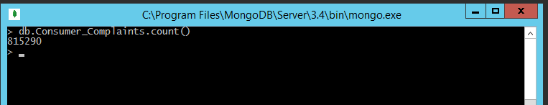

1. Select only required fields with where condition

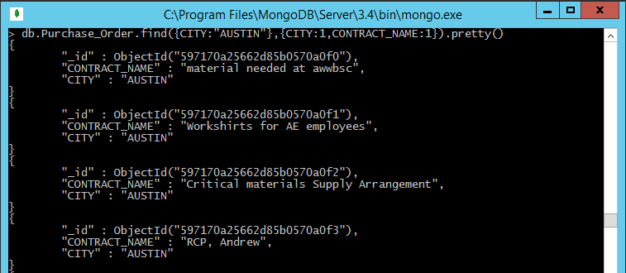

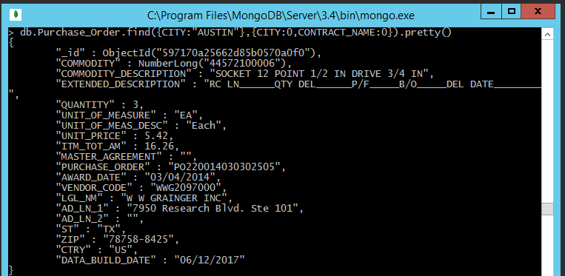

1. Select with where & and condition

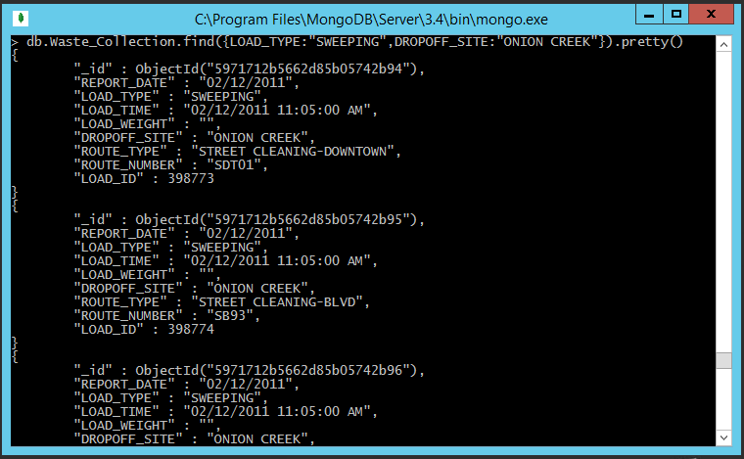

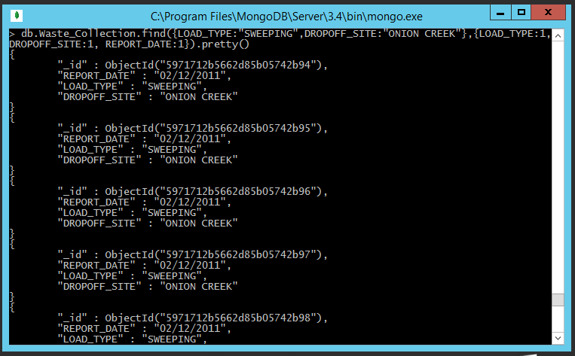

1. Select with where & or condition

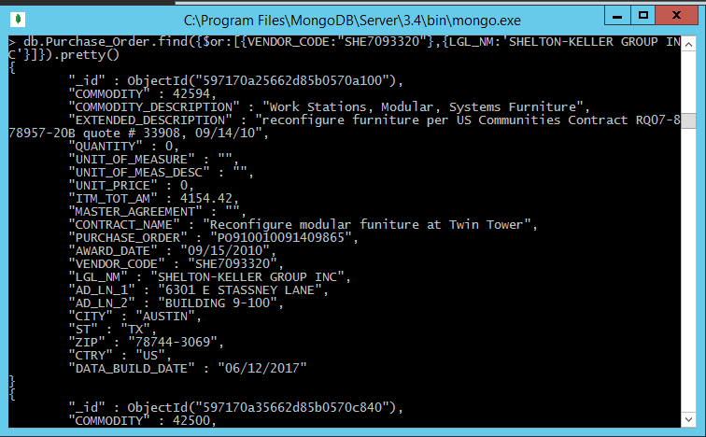

1. Select with Greater Than or Less Than condition

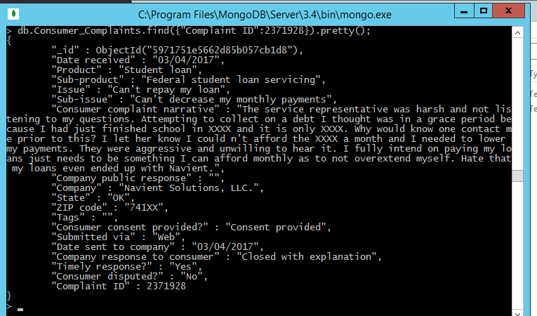

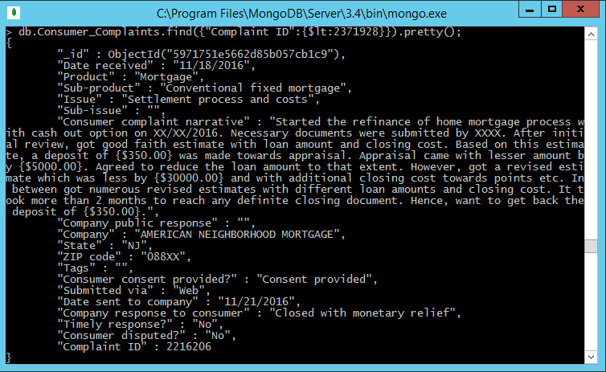

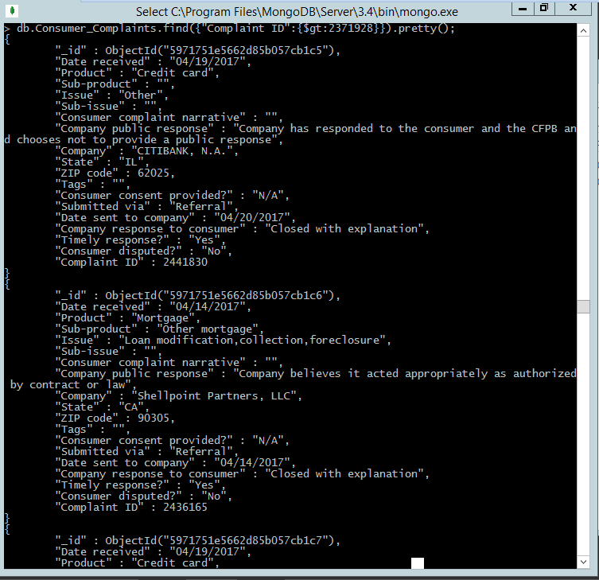

1. Modify Documents

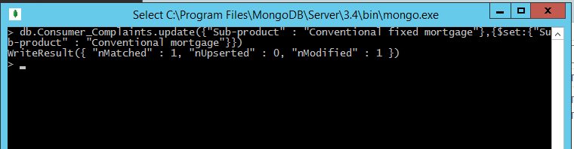

1. Deleting Documents

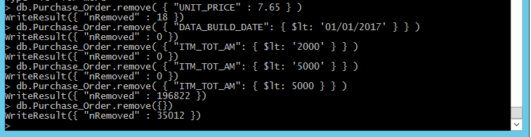

1. Aggregate

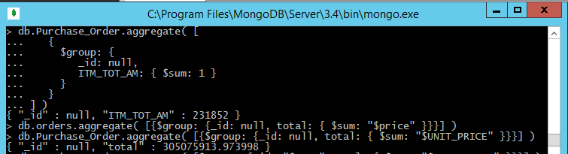

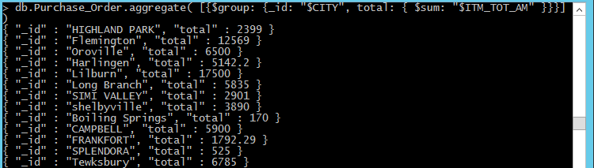

1. Sorting Documents

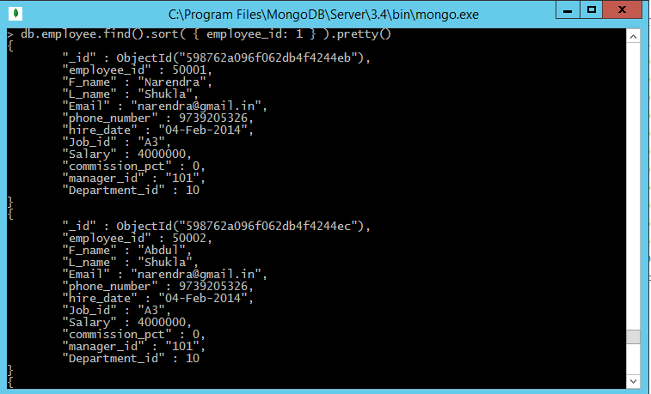

1. Indexing:
2. See all Indexes on a particular collection

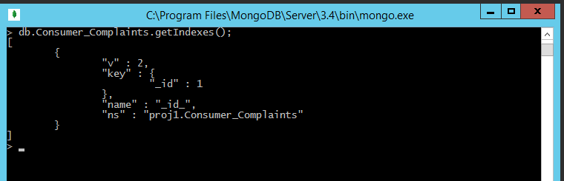

1. Single Field Indexes

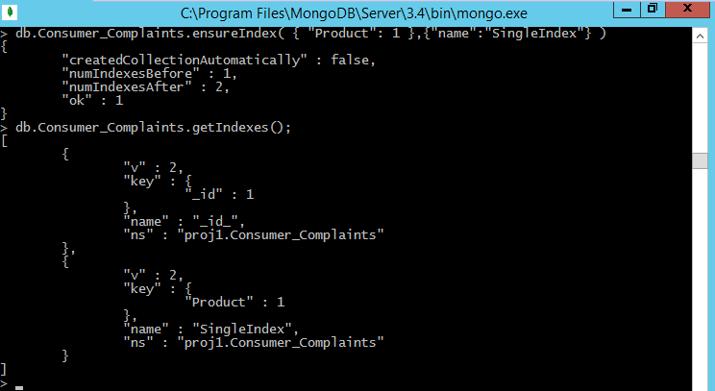

1. Compound Index

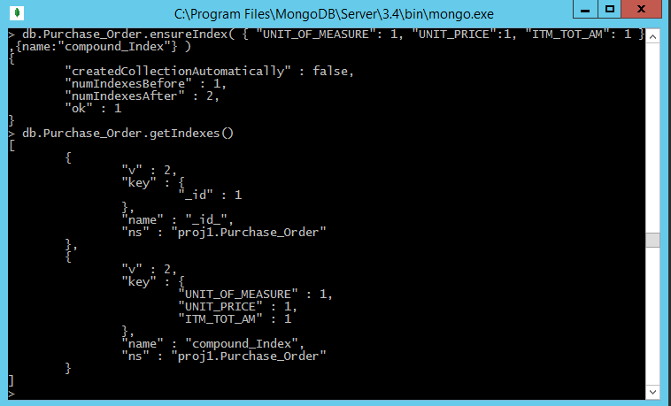

1. Hashed Indexes

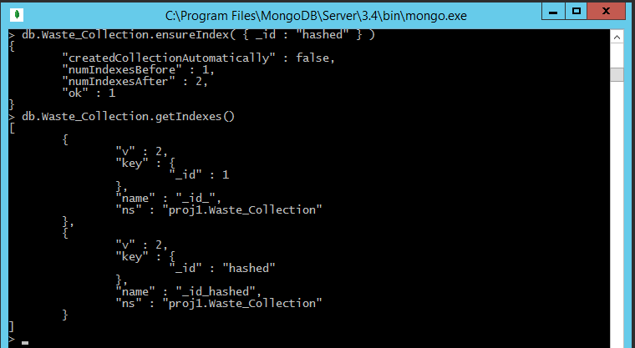

1. text Index

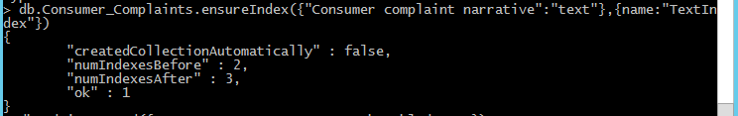

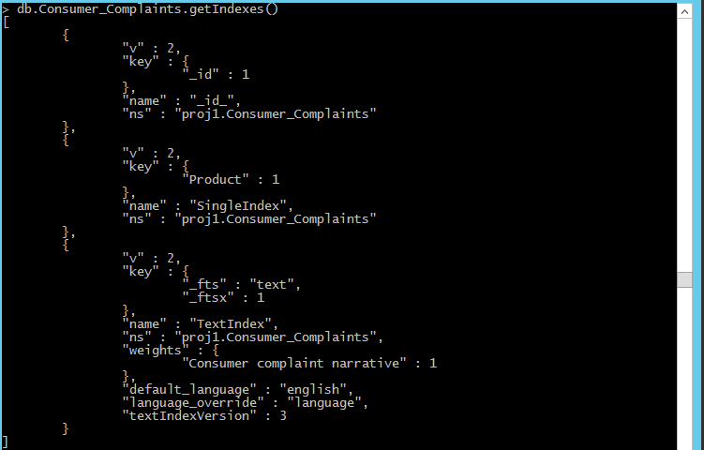

1. Unique Indexes

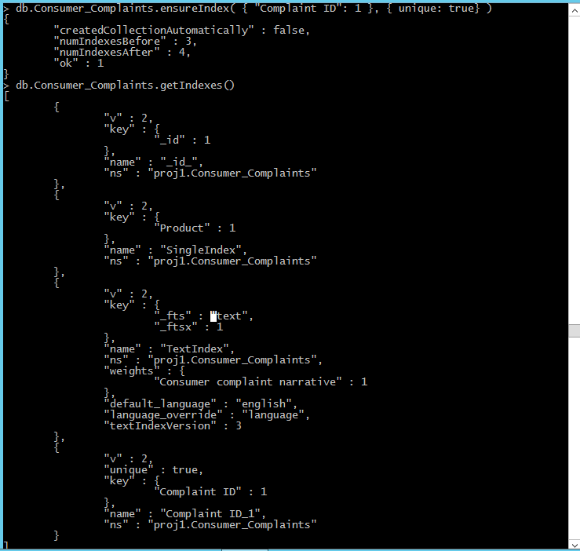

1. Sparse Index

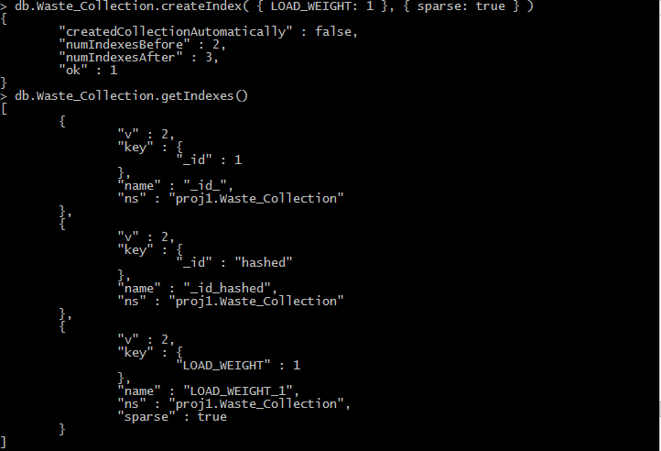

1. Hashed Index

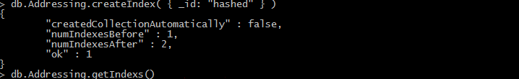

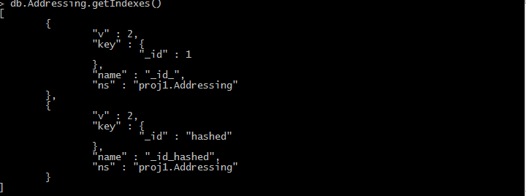

1. TTL Index

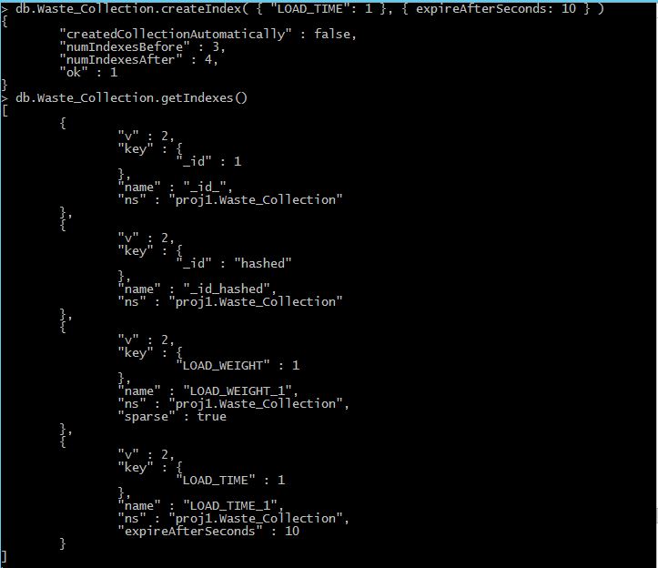

1. Partial Index

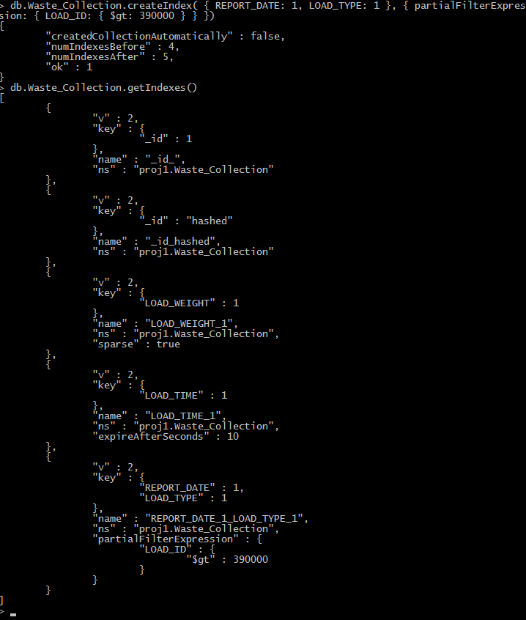

1. Build Indexes in the Background

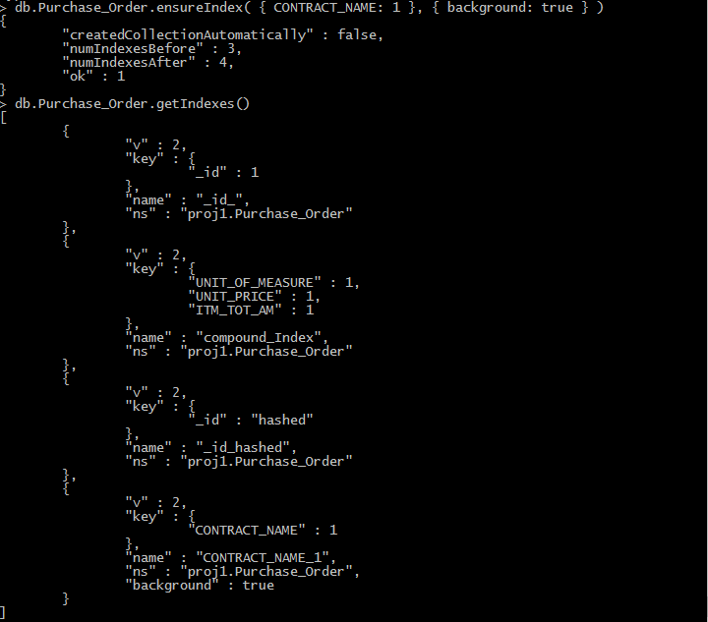

1. Remove Indexes



1. Rebuild Indexes

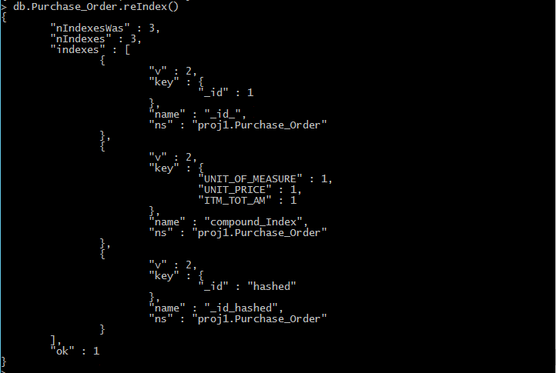

1. Measure Index Use

